**CURRICULUM VITAE**

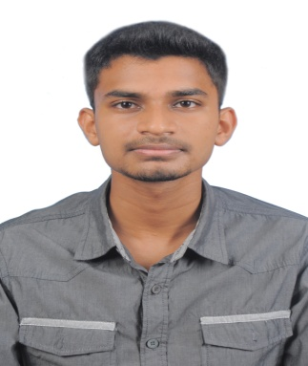**INDERAN A/L KRISHNAN**

**Date of Birth :** 13/01/1994

**Gender :**Male

**Nationality :**Malaysian

**Address:** No 11A Jalan 16/B Taman Jasmin 2,Kajang,43000, Selangor

**Mobile:** 016-9160537

**Email :**inderan130194@yahoo.com.my

|  |
| --- |
| **OBJECTIVE** |

* To secure a cooperative education in the field of Electrical Engineering or other engineering background that will challenge and strengthen my education and professional skills.

|  |
| --- |
| **PROFESSIONAL SKILLS** |

* Proficient in Microsoft Office (Word, Excel, and PowerPoint).
* Knowledgeable in Programming Language (C++) & other computer applications.
* Excellent in Bahasa Malaysia (Oral& writing), English (Oral & writing), Tamil (oral only).
* Autocad.
* PLC-S7-TK01

|  |
| --- |
| **EDUCATIONAL BACKGROUND** |

**Current: UNIVERSITI TENAGA NASIONAL(UNITEN)**

**(Diploma in Electrical Engineering)** 2014 – Present

Putrajaya, Malaysia

**Secondary: SMK TINGGI KAJANG**

**(Form 1 to Form 5)** 2007–2011

Kajang, Selangor

|  |
| --- |
| **INTERPERSONAL INFORMATION** |

* Enthusiastic self-starter and goal-driven achiever with strong initiative and commitment to excellence.
* Passionate to learn new things.
* Ready to take the challenges and can work under pressure.
* Fast learner, able to work well in group and willing to share experiences with others.
* Eager to help society and to contribute towards the development of a better nation.
* Good in time management and wise in decision making.

|  |
| --- |
| **WORKING EXPERIENCES** |

**18th Mac 2014 – 17th July 2014**

Power Cables Malaysia

Job scopes:

* Completing all sorts of assignments and tasks within the time range
* Paper Works
* Data Entry

**PART TIME**

Siri Krishna Enterprise

Job scopes:

* Site Supervisor.

|  |
| --- |
| **EXTRA CURRICULAR ACTIVITIES** |

* Secretary Of Badminton Club
* Secondary School Runner
* Secretary Of Football Club

|  |
| --- |
| **LANGUAGES** |

**Proficiency** (0=Poor - 10=Excellent)

**Language Spoken Written**

Malay 10 10

English 9 9

Tamil 10 0

|  |
| --- |
| **REFERENCE** |

* Deputy Dean of Student Affairs, College Of Foundation & General Studies, UNITEN:

Name : Dr. Rosmiza Mokhtar

Position : Deputy Dean of Student Affair(Putrajaya)

Email : rosmiza@uniten.edu.my

Company : College Of Foundation & General Studies

* Coodinator Of Industrial Training For Electrical Engineering

Name : Mrs. Redia Bte Mohd Redzuwan

Position : Coordinator Of Industrial Training

Email : [Redia@uniten.edu.my](mailto:Redia@uniten.edu.my)

Company : College Of Foundation & General Studies